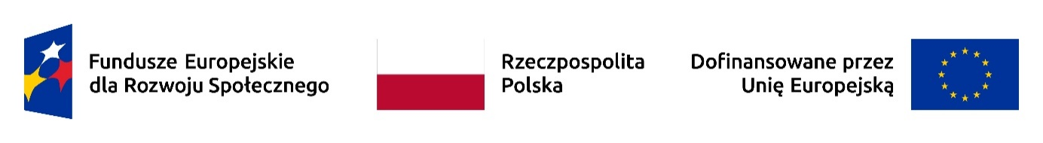

CERTIFICATE

Mrs/Mr
First name and surname

participated in

title of the event

during (from ........ to ......) in ......................... (venue of the event)

………………………………………………………………
date and signature of the organiser

Description of the learning outcomes:

Please describe the learning outcomes as a result of participating in the event using the following formula and catalogue of concepts. The defined learning outcomes should be easy to verify. It is therefore necessary to avoid too general and too complex expressions, the language of the description should be simple and precise.

Knowledge (knows and understands...)
e.g. Project participant knows/ searches for/ formulates/ explains/ recognises/ distinguishes names/ selects/ translates/ indicates …………

Skills (can...)
e.g. Project participant analyses/ selects/ uses/ links/ operates/ develops/ organises/ undertakes/ calculates/ carries out/ prepares/ solves/ implements/ verifies/ searches for/ designs …………

Social competences (is ready to...)
e.g. Project participant is eager to/ aware of/ able to/ oriented towards/ open to/ responsible for/ cares about/ proceeds according to/ strives for …………

………………………………………………………………
date and signature of the organiser

The learning outcome is what the learner knows, understands and can do as a result of learning, expressed in terms of knowledge, skills and social competence.
Knowledge – a collection of descriptions of objects and facts, principles, theories and practices acquired in the learning process and relating to the field of learning or professional activity.
Skills – the ability, assimilated in the learning process, to perform tasks and solve problems specific to the field of learning or professional activity.
Social competences – the ability to participate autonomously and responsibly in the professional and social life and to shape own development, taking into account the ethical context of own behavior.

